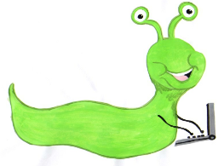

Lyng Primary School Knowledge Organiser

Information Technology



Autumn 1

Logo and Scratch

Year 2

Topic: IT

|  |  |
| --- | --- |
| What Goldilocks and Step On words will I use? | |
| **Spelling** | **Defintion** |
| Algorithm | A set of instructions that will reach a desired outcome. |
| Logo | A text-based coding language used to control an on-screen turtle to create a pattern. |
| Scratch | A block based coding programme that can be used to control a sprite on the screen. |
| Sprite | Image on the screen that can be made to move around, change appearance and react to their surroundings. |
| FD/BK | Move forward or backwards a distance of units. |
| RT/LT | Turn right or left a number of degrees. |
| Repeat | Repeat a set of instructions a specified number of times. |
| Code block | A group of commands that are joined together and are run when a specific condition is met or when an event occurs |
| Variable | The part of the algorithm that changes. |



**Aims of this unit**

* Understand what algorithms are, how they are implemented as programs on digital devices and that programs execute by following precise and ambiguous instructions.
* Create and debug simple programs.
* Use logical reasoning to predict the behaviour of simple programs using Turtle Logo and Scratch
* Create an algorithm
* To more or rotate the turtle
* Using the repeat command
* Including movement and sound
* Using the say command
* Using the green flag to start
* Using commands to change the backdrop and add sprites.

**Safeguarding**

Filtering and monitoring system is in place. Children will use their own log in details to track any misuse and to protect the child from harmful websites and pop ups. Children will be reminded of how to stay safe online and to use technology safely and respectfully and to tell a trusted adult if there is anything on their computer that makes them uncomfortable.

|  |
| --- |
| Outcomes |
| **All children**   * Draw lines of different lengths using fd command * Move blocks into the Script area * Snap blocks together to combine commands   **Most children**   * Turn the turtle using rt 90 and lt 90. * Draw squares and rectangles. * Create algorithms using blocks * Use repeat and green flag blocks to control   **Some children**   * Combine a range of blocks for a purpose * Use more than one sprite and combine algorithms. |

Autumn Term

Programming Turtle Logo and Scratch

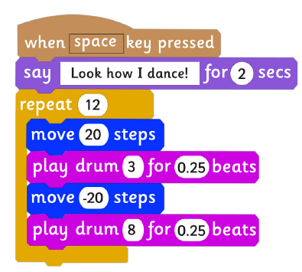

**In this unit…**

Children use the basic commands in Logo to move and draw using the turtle on screen and then further develop algorithms using the repeat command. These skills are then developed by teaching children to create algorithms in Scratch using a selection of blocks.

**Agreed outcome:**

Children will be able to navigate a map using Turtle logo and inputting the correct programming.